JOINS AND SET OPERATIONS

CREATE TABLES
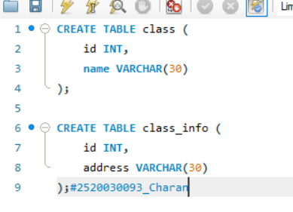
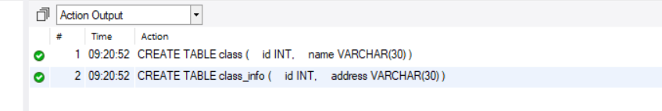

INSERT DATA
